**“DATA STRUCTURE AND ALGORITHM LAB”**

**A LAB RECORD SUBMITTED IN PARTIAL FULFILLMENT**

**OF THE REQUIREMENTS FOR THE SUBJECT**

**“DATA STRUCTURE AND ALGORITHM”**

**OF**

**Bachelor of Technology (Computer Science)**

**Submitted by:**

**Md merajul haque**

**B.Tech. (Computer Science) 2nd Year**

**Roll Number: 22BLCS005HY**

**Enrollment Number: A191069**

**Submitted to:**

**MOHTESHAM PASHA QUADRI**

**Assistant Professor**

**Department of Computer Science & Information Technology**

**Maulana Azad National Urdu University, Hyderabad**



**Department of Computer Science & Information Technology**

**Maulana Azad National Urdu University, Hyderabad**

**Maulana Azad National Urdu University**

**Gachibowli, Hyderabad, Telangana-500032 (India)**

**(Accredited with “A+” Grade by NAAC )**



**Certificate**

This is to certify that the lab record file by **MD MERAJUL HAQUE** bearing Enrollment Number **A191069** submitted in partial fulfillment of the requirements for the subject **“DATA STRUCTURE AND ALGORITHM LAB”** with course code **“BTCS360PCP”** in **Bachelor of Technology** (Computer Science) **3rd Semester** during 2022-23 at the **Department of Computer Science & Information Technology** is a bonafide laboratory work carried out by him under my supervision.

The results presented in this file have been verified and are found to be satisfactory.

**Signature of Internal Examiner Signature of External Examiner**

**INDEX / انڈیکس**

**LAB PRACTICAL RECORD / لیب عملی ریکار**

|  |  |  |
| --- | --- | --- |
| **S.No.** | **NAME OF EXPERIMRNT** | **PAGE NUMBER** |
| **1** | **Implement the Array Operation ( Insertion )** | **04 - 08** |
| **2** | **Implement the Array Operation ( Deletion )** |  |
| **3** | **Implementation of Stack Operation ( Push, Pop and Peak )** |  |
| **4** | **Implementation of Infix to Postfix** |  |
| **5** | **Implementation of Simple Queue Operation ( Enqueue and Dequeue )** |  |
| **6** | **Implementation of Circular Queue Operation ( Enqueue and Dequeue )** |  |
| **7** | **Sorting Technique ( Bubble Sort )** |  |
| **8** | **Sorting Technique ( Selection Sort )** |  |
| **9** | **Sorting Technique ( Insertion Sort )** |  |
| **10** | **Sorting Technique ( Quick Sort )** |  |

**) :- 01*پروگرام* No ( Program**

#### Aim (*مقصد*) :- IMPLEMENT THE ARRAY OPERATION (INSERTION)

**) :-*الگورتھم/طریقہ کار*Algorithm (**

### INSERTION AT THE END OF ARRAY:

* **Step 1: if UB=MAX, then array is overflow**
* **Step 2: Read DATA**
* **Step 3: UB=UB+1**
* **Step 4: arr[UB]=DATA**

### **INSERTION AT THE BEGINNING OF ARRAY:**

* **Step 1: if UB=MAX,then array is overflow Step 2: Read DATA**
* **Step 3: k=UB**
* **Step 4: Repeat step 5 while k>=LB Step 5: arr[K+1]=arr[k]**
* **K=k-1**
* **Step 6: arr[LB]=DATA**
* **Step 7: Stop**

### INSERTION AT THE GIVEN POSITION/LOCATION OF ARRAY:

* **Step 1: if UB=MAX,then array is overflow**
* **Step 2: Read DATA and LOCATION**
* **Step 3: k=UB**
* **Step 4: Repeat step 5 while k>=LOCATION Step 5: arr[K+1]=arr[k]**
* **K=k-1**
* **Step 6: arr[LOCATION]=DATA**
* **Step 7: Stop**

**Code(*کوڈ*) :-**

**#include<stdio.h>**

**#include <stdlib.h>**

**#define max 100**

**void insertion();**

**void insertionEnd();**

**void insertionBegin();**

**void insertionLoc();**

**void display();**

**struct array{**

**int ub;**

**int lb;**

**int a[max];**

**int size;**

**}a;**

**void main(){**

**int choice;**

**a.lb = -1;**

**a.ub = -1;**

**printf("Enter the size of Array : ");**

**scanf("%d",&a.size);**

**insertion();**

**}**

**void insertion(){**

**int choice,d;**

**do{**

**printf("\n1. Insert at the End\n2. Insert at the Begin\n3. Insert at the Location\n4. Display\n5. Exit\n ");**

**scanf("%d",&choice);**

**switch (choice){**

**case 1:**

**insertionEnd();**

**display();**

**break;**

**case 2:**

**insertionBegin();**

**display();**

**break;**

**case 3:**

**insertionLoc();**

**display();**

**break;**

**case 4:**

**display();**

**break;**

**case 5:**

**exit(0);**

**default:**

**printf("Wrong choice!!!");**

**break;**

**}**

**}while(choice!=5);**

**}**

**void insertionEnd(){**

**int data;**

**if(a.ub >= a.size){**

**printf("Array is Overflow!!");**

**}else{**

**printf("Enter element to be inserted : ");**

**scanf("%d",&data);**

**a.ub++;**

**a.a[a.ub] = data;**

**}**

**}**

**void insertionBegin(){**

**int data,i;**

**if(a.ub >= a.size){**

**printf("Array is Overflow!!");**

**}else{**

**printf("Enter element to be inserted : ");**

**scanf("%d",&data);**

**a.ub++;**

**for(i=0;i<=a.ub;i++){**

**a.a[i+1] = a.a[i];**

**}**

**a.a[0] = data;**

**}**

**}**

**void insertionLoc(){**

**int data,loc,i;**

**if(a.ub >= a.size){**

**printf("Array is Overflow!!");**

**}else{**

**printf("Enter element to be inserted : ");**

**scanf("%d",&data);**

**printf("Enter position : ");**

**scanf("%d",&loc);**

**a.ub++;**

**for(i=loc;i<=a.ub;i++){**

**a.a[i+1] = a.a[i];**

**}**

**a.a[loc] = data;**

**}**

**}**

**void display(){**

**int i;**

**if(a.ub == -1){**

**printf("No Elements!!");**

**}else{**

**printf("Array Elements : ");**

**for(i=0;i<=a.ub;i++){**

**printf("%d\t",a.a[i]);**

**}**

**}**

**}**

**Output(*نتیجہ*):-**

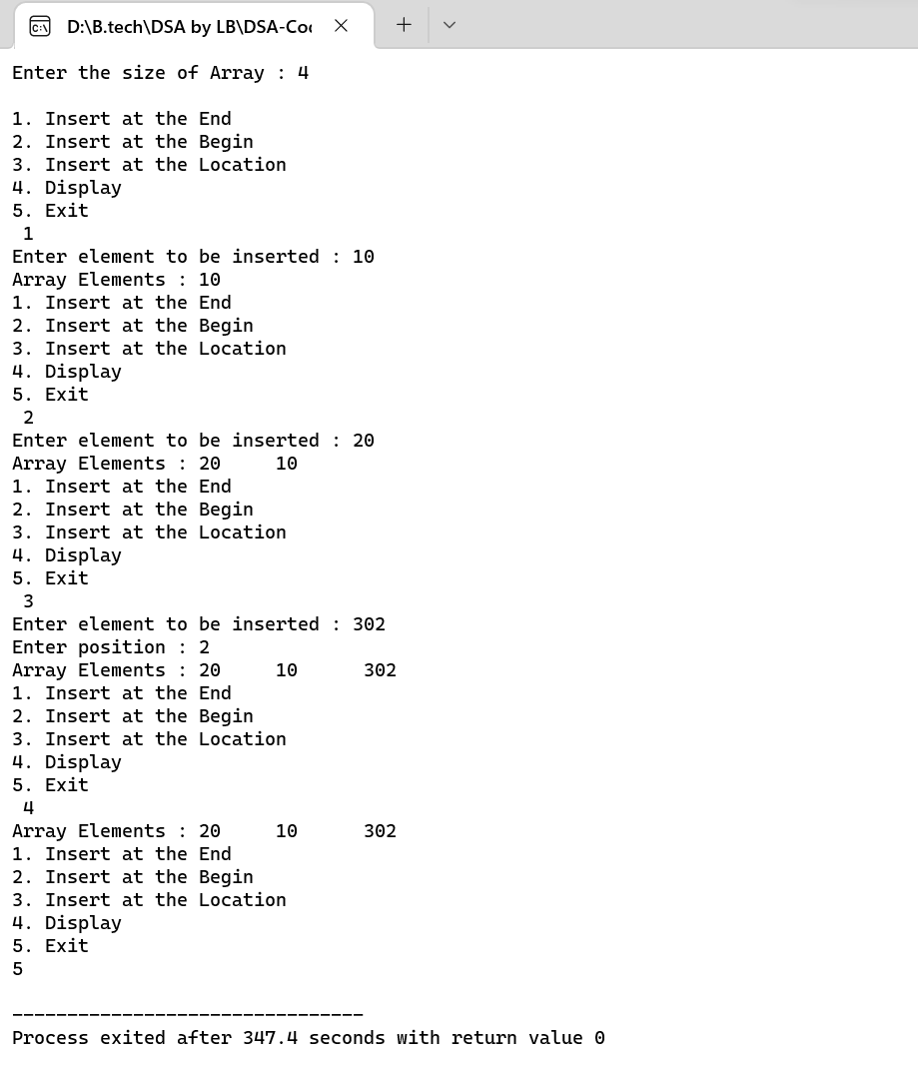

**) :- 02*پروگرام* No ( Program**

#### Aim (*مقصد*) :- **IMPLEMENT THE ARRAY OPERATION ( DELETION )**

**) :-*الگورتھم/طریقہ کار*Algorithm (**

**BEGINNING:**

* **Step 1: if UB==0, the array is underflow**
* **Step 2: k=LB**
* **Step 3: Repeat the step 4 while k<UB Step 4: arr[k]=arr[k+1]**
* **K=k+1**
* **Step 5: arr[UB]=NULL**
* **UB+UB-1**
* **Step 6: stop**

### DELETION AT END:

* **Step 1: if UB==0 then array is underflow**
* **Step 2: arr[UB]=NULL**
* **UB=UB-1**
* **Step 3: stop**

### DELETION AT THE GIVEN LOCATION:

* **Step 1: if UB==0, the array is underflow**
* **Step 2: Read LOCATION**
* **K=LOCATION**
* **Step 3: Repeat the step 4 while k<UB Step 4: arr[k]=arr[k+1]**
* **K=k+1**
* **Step 5: arr[UB]=NULL**
* **UB+UB-1**
* **Step 6: stop**

**Code(*کوڈ*) :-**

**#include<stdio.h>**

**#include <stdlib.h>**

**#define max 100**

**void deletion();**

**void deletionEnd();**

**void deletionBegin();**

**void deletionLoc();**

**void display();**

**struct array{**

**int ub;**

**int lb;**

**int a[max];**

**int size;**

**}a;**

**void main(){**

**int choice,i;**

**a.lb = -1;**

**printf("Enter size of Array : ");**

**scanf("%d",&a.size);**

**printf("Enter Elements : \n");**

**for(i=0;i<a.size;i++){**

**scanf("%d",&a.a[i]);**

**}**

**a.ub = a.size-1;**

**display();**

**deletion();**

**}**

**void deletion(){**

**int choice,d;**

**do{**

**printf("\n1. Delete at the End\n2. Delete at the Begin\n3. Delete at the Location\n4. Display\n5. Exit\n ");**

**scanf("%d",&choice);**

**switch (choice){**

**case 1:**

**deletionEnd();**

**display();**

**break;**

**case 2:**

**deletionBegin();**

**display();**

**break;**

**case 3:**

**deletionLoc();**

**display();**

**break;**

**case 4:**

**display();**

**break;**

**case 5:**

**exit(0);**

**default:**

**printf("Wrong choice!!!");**

**break;**

**}**

**}while(choice!=5);**

**}**

**void deletionEnd(){**

**int data;**

**if(a.ub == a.lb){**

**printf("Array is Underflow!!");**

**}else{**

**printf("Deleted Element : %d\n",a.a[a.ub]);**

**a.ub--;**

**}**

**}**

**void deletionBegin(){**

**int data,i;**

**if(a.ub == a.lb){**

**printf("Array is Underflow!!");**

**}else{**

**printf("Deleted Element : %d\n",a.a[0]);**

**for(i=0;i<a.ub;i++){**

**a.a[i] = a.a[i+1];**

**}**

**a.ub--;**

**}**

**}**

**void deletionLoc(){**

**int data,loc,i;**

**if(a.ub == a.lb){**

**printf("Array is Underflow!!");**

**}else{**

**printf("Enter position : ");**

**scanf("%d",&loc);**

**printf("Deleted Element : %d\n",a.a[loc-1]);**

**for(i=loc-1;i<a.ub;i++){**

**a.a[i] = a.a[i+1];**

**}**

**a.ub--;**

**}**

**}**

**void display(){**

**int i;**

**if(a.ub == -1){**

**printf("No Elements!!");**

**}else{**

**printf("Array Elements : ");**

**for(i=0;i<=a.ub;i++){**

**printf("%d\t",a.a[i]);**

**}**

**}**

**}**

**Output(*نتیجہ*):-**

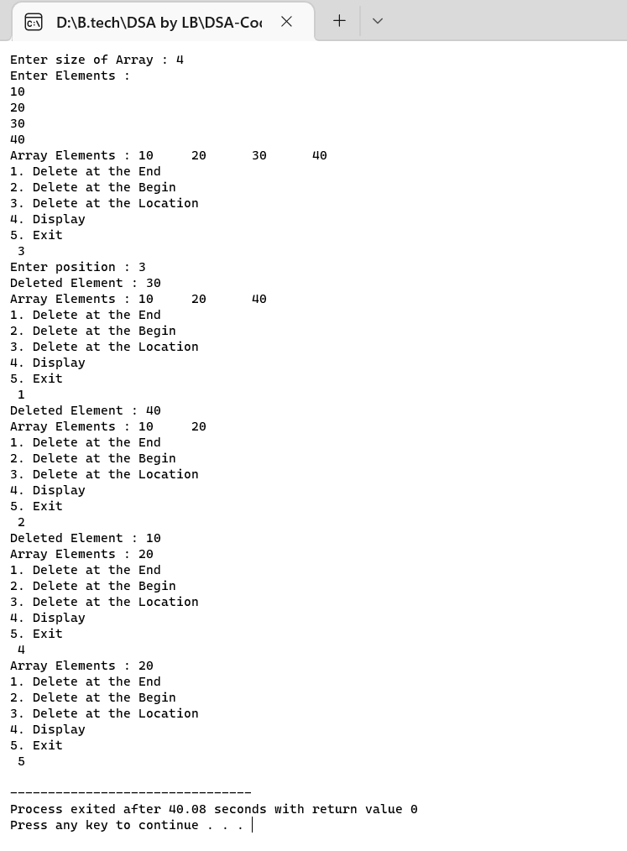

**) :- 03*پروگرام* No ( Program**

#### Aim (*مقصد*) :- **Implementation of Stack Operation ( Push, Pop and Peak )**

**) :-*الگورتھم/طریقہ کار*Algorithm (**

**Push Operation**

* **The process of putting a new data element onto stack is known as a Push Operation. Push operation involves a series of steps −**
* **Step 1 − Checks if the stack is full.**
* **Step 2 − If the stack is full, produces an error and exit.**
* **Step 3 − If the stack is not full, increments top to point next empty space. Step 4 − Adds data element to the stack location, where top is pointing. Step 5 − Returns success.**

**POP OPERATION**

* **Step 1 − Checks if the stack is empty.**
* **Step 2 − If the stack is empty, produces an error and exit.**
* **Step 3 − If the stack is not empty, accesses the data element at which top is pointing.**
* **Step 4 − Decreases the value of top by 1.**
* **Step 5 − Returns success.**

### PEAK OPERATION

* **Step 1:begin procedure peek**
* **Step 2: return stack[top]**
* **Step 3: end procedure**

**Code(*کوڈ*) :-**

**#include<stdio.h>**

**#define max 100**

**void push();**

**void pop();**

**void display();**

**void peek();**

**struct stack{**

**int top;**

**int arr[max];**

**}s;**

**void main(){**

**int x;**

**s.top = -1;**

**do{**

**printf("\n1. Push\n2. Pop\n3. Display\n4. Peek\n5. Exit\n");**

**printf("Choose Option : ");**

**scanf("%d",&x);**

**switch(x){**

**case 1:**

**push();**

**display();**

**break;**

**case 2:**

**pop();**

**display();**

**break;**

**case 3:**

**display();**

**break;**

**case 4:**

**peek();**

**break;**

**case 5:**

**break;**

**}**

**}while(x!=5);**

**}**

**void push(){**

**int data;**

**if(s.top == max-1){**

**printf("Stack Overflow!!");**

**}**

**else{**

**printf("Enter the element to be pushed : ");**

**scanf("%d",&data);**

**s.top++;**

**s.arr[s.top] = data;**

**}**

**}**

**void pop(){**

**int data;**

**if(s.top == -1){**

**printf("Stack Underflow!!\n");**

**}**

**else{**

**data = s.arr[s.top];**

**s.top--;**

**printf("Popped Element is %d\n",data);**

**}**

**}**

**void display(){**

**int i=0;**

**if(s.top == -1){**

**printf("Stack Underflow!!");**

**}else{**

**printf("Elements are : ");**

**for(i=0;i<=s.top;i++){**

**printf("%d\t",s.arr[i]);**

**}**

**}**

**}**

**void peek(){**

**if(s.top == -1){**

**printf("Stack Underflow!!");**

**}else{**

**printf("Peek Element is %d",s.arr[s.top]);**

**}**

**}**

**Output(*نتیجہ*):-**

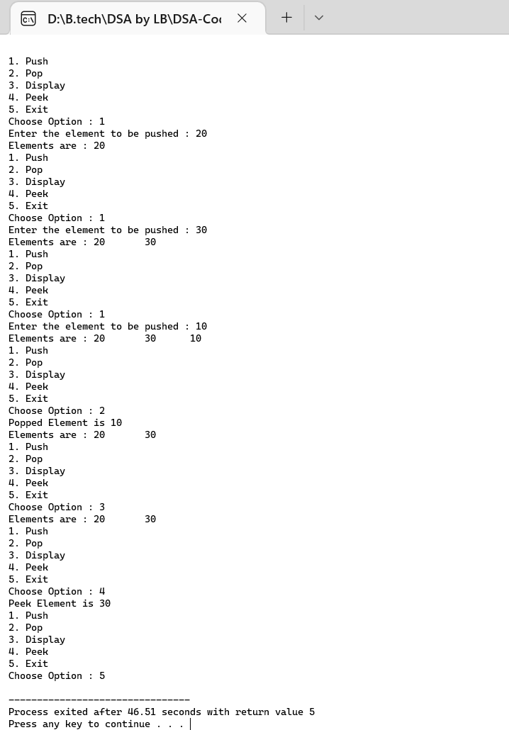

**) :- 0*پروگرام* No ( Program**

#### Aim (*مقصد*) :- Implementation of simple queue operation( Enqueue and Dequeue )

**) :-*الگورتھم/طریقہ کار*Algorithm (**

**Queue operations work as follows :**

* **two pointers FRONT and REAR**
* **FRONT track the first element of the queue**
* **REAR track the last element of the queue**
* **initially, set value of FRONT and REAR to -1**

**Enqueue Operation :**

* **Step 1: check if the queue is full**
* **Step 2: for the first element, set the value of FRONT to 0**
* **Step 3: increase the REAR index by 1**
* **Step 4: add the new element in the position pointed to by REAR**

**Dequeue Operation :**

* **Step 1: check if the queue is empty**
* **Step 2: return the value pointed by FRONT**
* **Step 3: increase the FRONT index by 1**
* **Step 4: for the last element, reset the values of FRONT and REAR to -1**

**Code(*کوڈ*) :-**

**#include<stdio.h>**

**#include<stdlib.h>**

**#include<conio.h>**

**#define max 100**

**//declaring function globally**

**void enQueue();**

**void deQueue();**

**void display();**

**int Queue[max], front = -1, rear = -1;**

**int i,value;**

**int main(){**

**int choice;**

**do{**

**printf("\n1. EnQueue \n2. DeQueue \n3. Display\n4. Exit\nEnter Your Choice : ");**

**scanf("%d",&choice);**

**switch (choice)**

**{**

**case 1:**

**enQueue();**

**display();**

**break;**

**case 2:**

**deQueue();**

**display();**

**break;**

**case 3:**

**display();**

**break;**

**case 4:**

**exit(0);**

**default:**

**printf("Wrong selection ! \n");**

**break;**

**}**

**}while(choice!=4);**

**return 0;**

**}**

**void enQueue(){**

**int data;**

**if(rear == max-1){**

**printf("Queue is full!!");**

**}else{**

**printf("Enter data to enQueue : ");**

**scanf("%d",&data);**

**if(front == -1){**

**front = 0;**

**}**

**rear++;**

**Queue[rear] = data;**

**}**

**}**

**void deQueue(){**

**if(front == -1){**

**printf("Queue is empty !!\n");**

**}else{**

**printf("Deleted : %d\n",Queue[front]);**

**front++;**

**if(front>rear){**

**front = rear = -1;**

**}**

**}**

**}**

**void display(){**

**if(rear == -1){**

**printf("Queue is Empty !!! \n");**

**}else{**

**int i;**

**printf("Queue elements : ");**

**for(i = front; i<= rear; i++){**

**printf("%d\t", Queue[i]);**

**}**

**}**

**}**

**Output(*نتیجہ*):-**

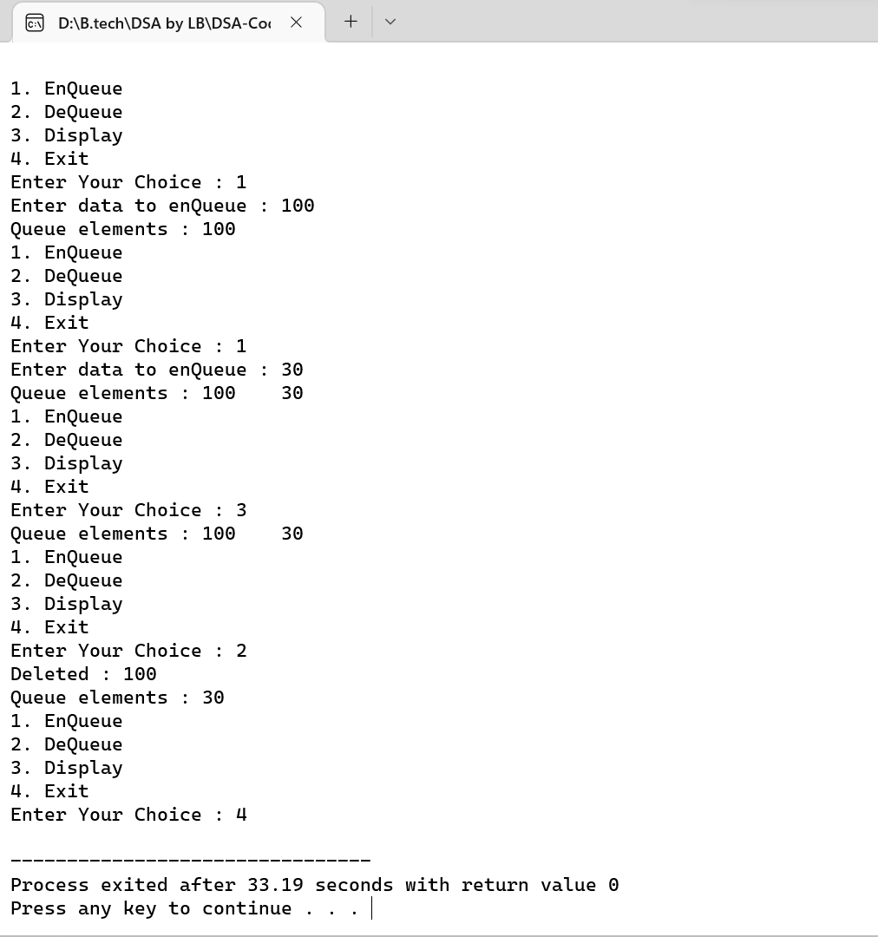

**) :- 0*پروگرام* No ( Program**

#### **Aim (*مقصد*) :-**

**C program for implementation of Bubble sort**

**) :-*الگورتھم/طریقہ کار*Algorithm (**

1. **begin BubbleSort(arr)**
2. **for all array elements**
3. **if arr[i] > arr[i+1]**
4. **swap(arr[i], arr[i+1])**
5. **end if**
6. **end for**
7. **return arr**
8. **end BubbleSort**

**Code(*کوڈ*) :-**

**// C program for implementation of Bubble sort**

**#include<stdio.h>**

**void swap(int *xp, int *yp)**

**{**

**int temp = *xp;**

**\*xp = *yp;**

**\*yp = temp;**

**}**

**void bubbleSort(int arr[], int n)**

**{**

**int i, j;**

**for (i = 0; i<n-1; i++)**

**for (j = 0; j<n-i-1; j++)**

**if (arr[j] >arr[j+1])**

**swap(&arr[j], &arr[j+1]);**

**}**

**void printArray(int arr[], int size)**

**{**

**int i;**

**for (i=0; i<size; i++)**

**printf("%d ", arr[i]);**

**printf("\n");**

**}**

**int main()**

**{**

**int arr[100], n,i;**

**printf("Enter the no. of element you want to Sort. \n");**

**scanf("%d", &n);**

**printf("Now Enter the Element : \n");**

**for(i = 0; i<n; i++){**

**scanf("%d", &arr[i]);**

**}**

**bubbleSort(arr, n);**

**printf("Sorted array: \n");**

**printArray(arr, n);**

**return 0;**

**}**

**Output(*نتیجہ*):-**

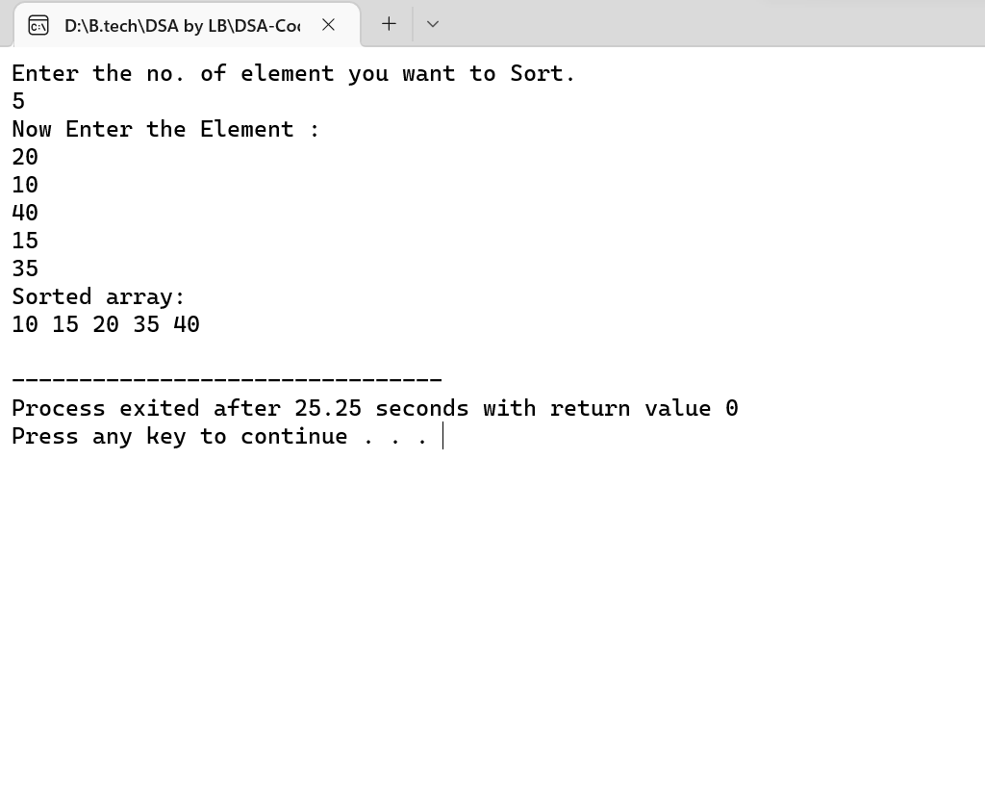

**) :- 01*پروگرام* No ( Program**

**Aim (*مقصد*) :- Implementation of selection sort**

**) :-*الگورتھم/طریقہ کار*Algorithm (**

* **Step 1 - If the element is the first element, assume that it is already sorted. Return 1.**
* **Step2 - Pick the next element, and store it separately in a key.**
* **Step3 - Now, compare the key with all elements in the sorted array.**
* **Step 4 - If the element in the sorted array is smaller than the current element, then move to the next element. Else, shift greater elements in the array towards the right.**
* **Step 5 - Insert the value.**
* **Step 6 - Repeat until the array is sorted.**

**Code(*کوڈ*) :-**

**// C program for implementation of selection sort**

**#include<stdio.h>**

**void swap(int *xp, int *yp)**

**{**

**int temp = *xp;**

**\*xp = *yp;**

**\*yp = temp;**

**}**

**void selectionSort(int arr[], int n)**

**{**

**int i, j, min_idx;**

**// One by one move boundary of unsorted subarray**

**for (i = 0; i<n-1; i++)**

**{**

**// Find the minimum element in unsorted array**

**min_idx = i;**

**for (j = i+1; j<n; j++)**

**if (arr[j] <arr[min_idx])**

**min_idx = j;**

**// Swap the found minimum element with the first element**

**swap(&arr[min_idx], &arr[i]);**

**}**

**}**

**/* Function to print an array */**

**void printArray(int arr[], int size)**

**{**

**int i;**

**for (i=0; i<size; i++)**

**printf("%d ", arr[i]);**

**printf("\n");**

**}**

**int main()**

**{**

**int arr[100], n,i;**

**printf("Enter the no. of element you want to Sort. \n");**

**scanf("%d", &n);**

**printf("Now Enter the Element : \n");**

**for(i = 0; i<n; i++){**

**scanf("%d", &arr[i]);**

**}**

**selectionSort(arr, n);**

**printf("Sorted array: \n");**

**printArray(arr, n);**

**return 0;**

**}**

**Output(*نتیجہ*):-**

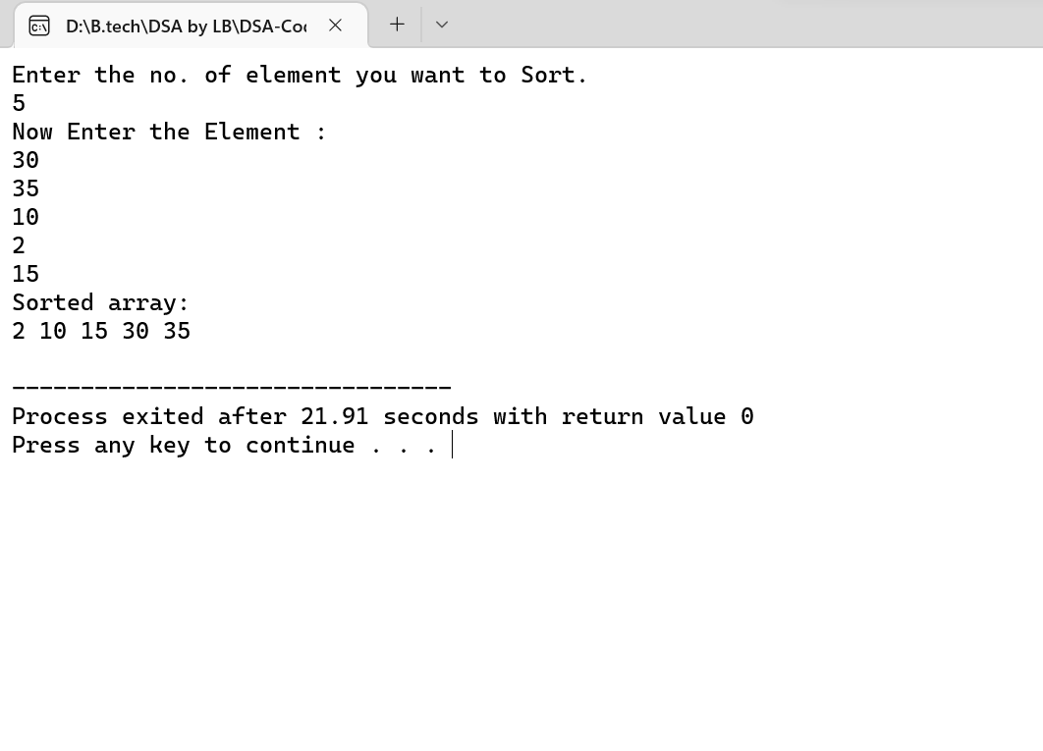

**) :- 01*پروگرام* No ( Program**

#### Aim (*مقصد*) :- SORTING TECHNIQUE (INSERTION SORT)

**) :-*الگورتھم/طریقہ کار*Algorithm (**

* **Step 1 - If the element is the first element, assume that it is already sorted. Return 1.**
* **Step2 - Pick the next element, and store it separately in a key. Step3 - Now, compare the key with all elements in the sorted array.**
* **Step 4 - If the element in the sorted array is smaller than the current element, then move to the next element. Else, shift greater elements in the array towards the right.**
* **Step 5 - Insert the value.**
* **Step 6 - Repeat until the array is sorted.**

**Code(*کوڈ*) :-**

**// C program for insertion sort**

**#include<math.h>**

**#include<stdio.h>**

**void insertionSort(int arr[], int n)**

**{**

**int i, key, j;**

**for (i = 1; i<n; i++)**

**{**

**key = arr[i];**

**j = i - 1;**

**while (j>= 0 && arr[j]>key){**

**arr[j + 1] = arr[j];**

**j = j - 1;**

**}**

**arr[j + 1] = key;**

**}**

**}**

**void display(int arr[], int n)**

**{**

**int i;**

**printf("Sorted array: ");**

**for (i = 0; i<n; i++){**

**printf("%d\t", arr[i]);**

**}**

**}**

**int main()**

**{**

**int arr[100], n,i;**

**printf("Enter the number of element you want to Sort : ");**

**scanf("%d", &n);**

**printf("Now Enter the Element : \n");**

**for(i = 0; i<n; i++){**

**scanf("%d", &arr[i]);**

**}**

**insertionSort(arr, n);**

**display(arr, n);**

**return 0;**

**}**

**Output(*نتیجہ*):-**

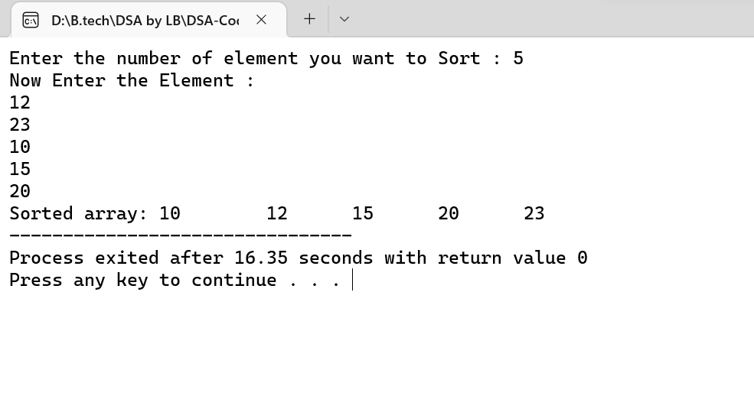

**) :- 01*پروگرام* No ( Program**

#### Aim (*مقصد*) :-

**) :-*الگورتھم/طریقہ کار*Algorithm (**

**Code(*کوڈ*) :-**

**Output(*نتیجہ*):-**